**MISION TIC “CICLO 4”**

**DESARROLLO DE SOFTWARE  
Equipo: 12**

**Brian Benedetty Guzmán**

**GitHub:** [**https://github.com/BBenguz/Ciclo-4**](https://github.com/BBenguz/Ciclo-4)

**OPEN JDK/11**

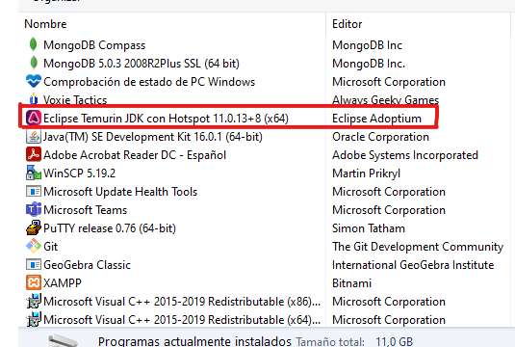

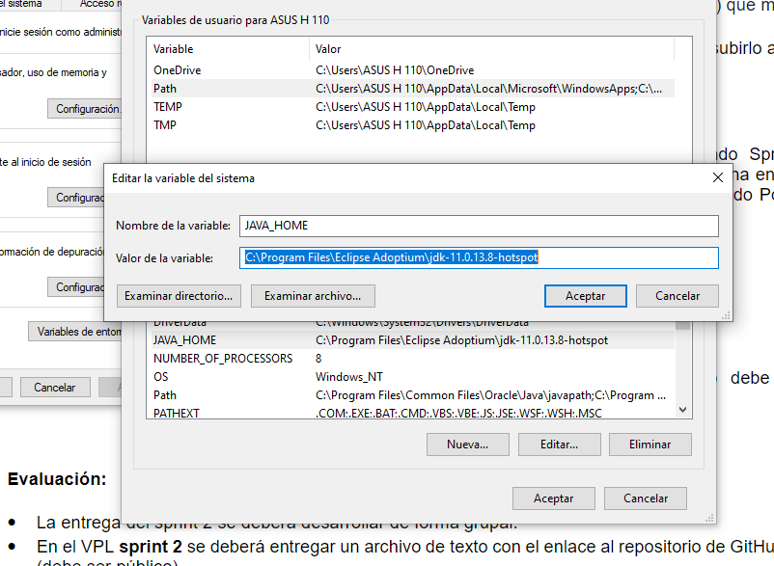

**Mongol DB**

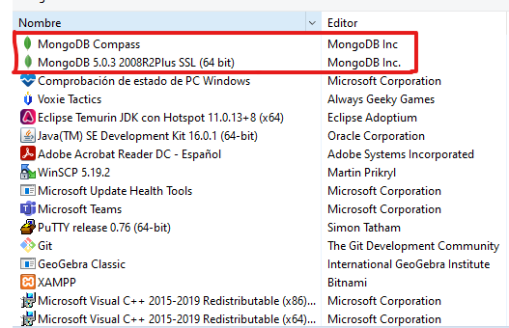

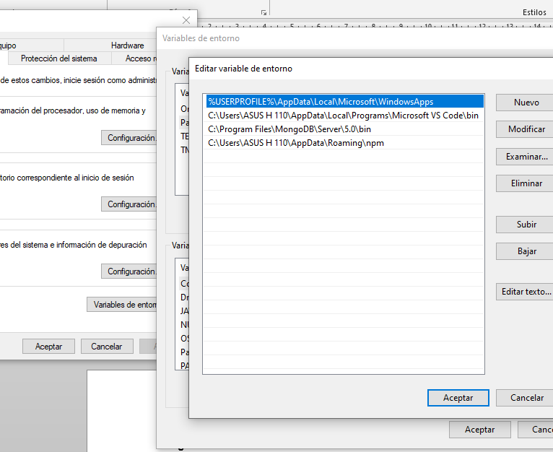

**SpringBoot**

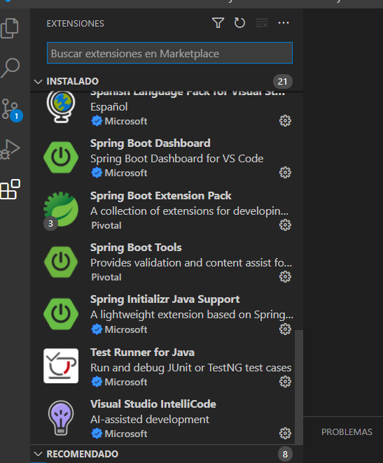

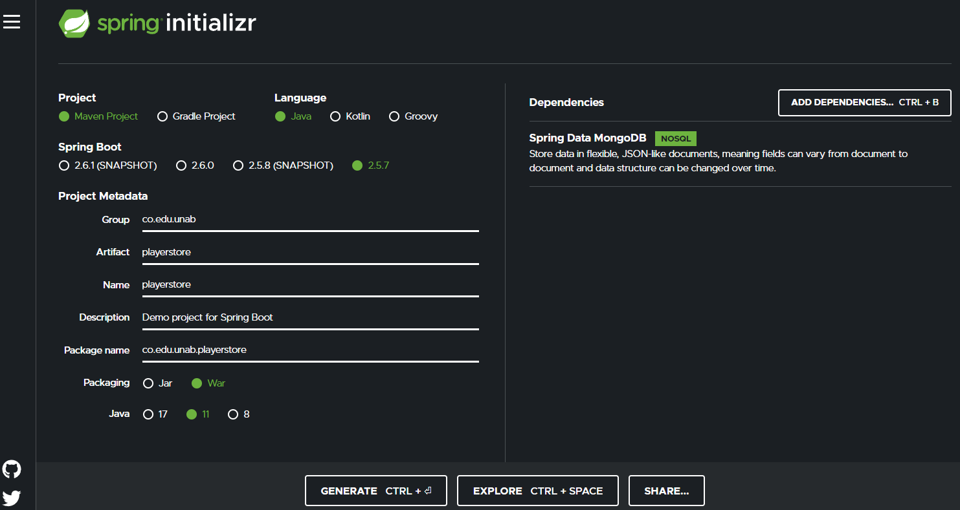

**Maven**

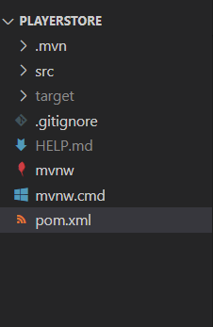

**Postman**

